**Department of Computer Science and Engineering**

|  |  |
| --- | --- |
| **Course Code: CSE 420** | **Credits: 1.5** |
| **Course Name: Compiler Design** | **Semester: Fall’ 18** |

**Lab 05**

**Introduction**

**I. Topic Overview:**

The lab is designed to introduce the students to the basics concept of a compiler Design. As part of this activity students will write code to parse a fixed set of CFG using LL(1) parsing table using any built in libraries. Basic techniques of coding and required tools will also be shown to students. We will only implement the parsing table for the LL(1) parser example in class.

**II. Lesson Fit:**

The lab gives a hand on experience of the knowledge of theory class.

**III. Learning Outcome:**

After this lecture, the students will be able to:

a. Understand and visualize the syntax analysis phase.

b. Implement parsing table for a CFG.

c. Creating own version of top down/LL(1) parsing algorithm that works for a given parsing table.

**IV. Anticipated Challenges and Possible Solutions**

a. Mapping the parsing table into code will be challenging.

**Possible Solutions:**

a. Store the parsing table in a class format.

b. Take the parsing table as input.

c. you just need to store the production head and production body.

**V. Acceptance and Evaluation**

If a task is a continuing task and one couldn’t finish within time limit, he/she will continue from there in the next Lab, or be given as a home work. He/ she have to submit the code and have to face a short viva. A deduction of 30% marks is applicable for late submission. The marks distribution is as follows:

Code: 0%

Viva: 100%

**VI. Activity Detail**

**Activity Detail**

1. **Hour: 1**

**Discussion:** Input the parsing table. Please not that you don’t have to compute first and follow.

**Problem Task: Task 1 (page 3-4)**

1. **Hour: 2**

**Discussion:** Implement the top down parsing algorithm and show the parsing as shown in the sample output using stack.

**Problem Task: Task 2 (page 3-4)**

**b. Hour: 3**

**Discussion:** Code the top down parsing algorithm with error recovery

**Problem Task: Task 3 (page 3-4)**

**Assignment 3: Problem Description**

In this assignment, you will work on parsing. For simplicity, we will assume that there is a fixed grammar that we did in theory class.

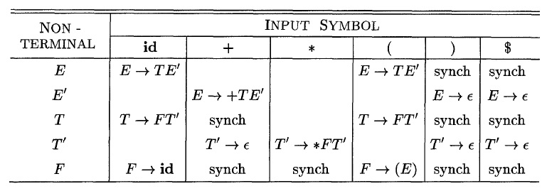

Correction:

+

E’->TE’

T’->e

**Lab 3: Activity List**

**Task 1:** Take the top down parsing table as input.

**Task 2:** Show parsing for any input string as output.

**Task 3:** Bonus for implementing top down parsing with panic mode error recovery.

**Input:**

1

id+id*id

**Output:**

